Product Champion
IT Efficiency vs. IT Effectiveness
In today's ever-changing IT landscape, enterprises frequently focus their measurement efforts on the efficiency of IT services delivered. This is particularly true during economic downturns in which IT managers are directed to do more with less funding. Equally important, however, is the evaluation of IT effectiveness. Whereas an efficiency analysis assesses whether an IS organization is "doing things right," an effectiveness analysis determines whether an IS organization is "doing the right things." If the IT services do not accomplish the enterprise business goals and objectives, it can be costly. An IT effectiveness assessment addresses this extremely important issue. Thus, best-in-class IT managers measure both efficiency and effectiveness.
IT efficiency is measured through cost comparisons. Costs are analyzed and comparisons are made with other enterprises to determine whether the IT services delivered at one IS organization are more or less efficient than those of peers delivering the same services. Using a standard cost model allows meaningful comparisons for disparate IS organizations to evaluate the efficiencies of their IT services. Gartner Measurement's Rapid Assessment for Total IT Expenditure performs a high-level cost-efficiency analysis across all functional areas of IT. Enterprises in the database performing similar workloads are compared with each other. Using this information as a baseline, Gartner evaluates each functional IT area to determine specific strategies for improved performance.
However, IT effectiveness often is more difficult to measure because the data analyzed is qualitative rather than quantitative. With the Gartner Measurement Rapid Assessment for Customer Satisfaction analysis, end users evaluate the IT services delivered. Through importance rankings and satisfaction ratings, the survey determines overall IT effectiveness. In addition to highlighting areas of strength and weakness, the results provide a roadmap for specific strategies for improved performance.
Several challenges arise when attempting to measure IT effectiveness through a satisfaction survey. For example:
- If a survey is conducted and the results are not communicated to the end users, it will result in withdrawal and cynicism.
- If the criteria are not defined clearly, they will result in a collection of useless data.
- If the survey fails to ask for importance weightings, it will result in no prioritization of the issues.
- If the survey is too long, it will result in survey fatigue and incomplete responses.
- If the survey does not convert the data into action plans, it will result in no improvement.
It is important to understand these challenges and how they can be overcome (see Figure 1).
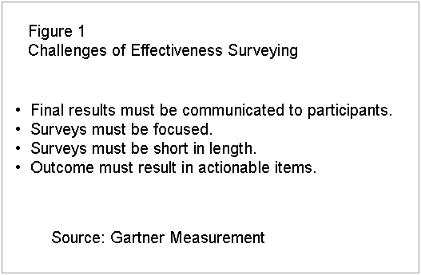
Figure 1.
Final results must be communicated to participants. — Most importantly, IS organizations must communicate the results to the end users. Conducting a survey implies that the input of those surveyed is important. If the results are not communicated to the end users and changes do not occur, credibility is lost. A survey creates an expectation that input is important and will generate actions. Thus, communicating the results and delivering on the action plans are critical for a successful program and for any future end-user participation.
Surveys must be focused. — To ensure that a questionnaire is concise and targeted, it is crucial that its focus is on the delivery of IT services. Respondents do not want to waste their time answering questions that are not important to them and that do not affect them. Rather than increasing satisfaction, unfocused questionnaires actually may decrease satisfaction. Thus, a survey must include a comprehensive, non-overlapping set of evaluation criteria. This allows respondents to answer fully all questions about a particular service and provide a complete picture of the effectiveness of the IT services delivered.
Surveys must be short in length. — A survey must be constructed such that maximum data is captured within the least amount of time. Furthermore, a survey must collect not only satisfaction levels regarding IT services delivered but also the importance of those services to the end users. It is essential to capture the data within 10 minutes to 15 minutes. Otherwise, fatigue, impatience and incomplete surveys may result.
Outcome must result in actionable items. — Linked to each importance weighting and satisfaction score should be a justification statement and suggestion for improvement supplied directly by the respondents. These justification statements are ranked by priority, which facilitates the development of actionable improvement strategies and action plans with the greatest potential for improvement.
In the Gartner Measurement comparative database of enterprises, IT effectiveness results are aligned with IT efficiency results to provide a strategic perspective for management. If an IS organization is too focused on "doing the right things," the outcome can be extremely high satisfaction and very low cost-efficiency. Conversely, a concentrated effort on "doing things right" can result in especially high cost-efficiency with extremely dissatisfied end users. Either extreme may be costly to an enterprise. The goal is to strike the optimum balance between the two areas. For example, in Figure 2 enterprises in the upper-right-hand quadrant have been successful in finding the equilibrium between IT efficiency and effectiveness.
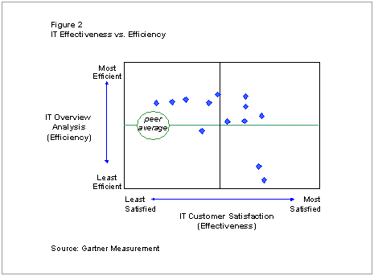
Figure 2.
Especially during economic downturns, it is critical to establish the value of IT. Measurement results from an efficiency and effectiveness evaluation provide a valuable communication vehicle to demonstrate the cost and significance of IT. Because the appropriate balance between efficiency and effectiveness is essential to the success of a business, communicating value is best achieved in stages. During the first phase, a baseline is established. In the second stage, year-over-year performance is underscored so that future trending, comparisons and decisions can be made. Examples of attaining a balance of cost-efficiency and effectiveness follow.
Case Study #1
Although excelling in several areas, a combined total IT expenditure and customer satisfaction assessment revealed inefficiencies and ineffectiveness in the help desk and distributed computing environments. With the support of a measurement baseline and Gartner Measurement's recommendations, action plans were created and implemented. An analysis during the subsequent year underscored improvements in efficiencies and effectiveness, thus clearly delineating the cost and benefit of the IT investment decisions.
It is imperative that a baseline is established. Many IS organizations have based decisions on the false assumption that they "knew" where they would fall on the chart in Figure 2. However, reality and perception can differ substantially. Unless a benchmark is established, the results can be disastrous.
Case Study #2
After measurement, another delighted IS organization discovered that they fell within the upper-right-hand quadrant in Figure 2. However, extreme caution was advised for any communication of the outcome. Despite excellent results, further analysis revealed that this would change rapidly if end-user issues in the desktop arena (e.g., outdated equipment and older versions of software) were not addressed shortly.
Although many IS organizations would perceive the "right" place as being positioned in the upper-right-hand quadrant, ultimately, the "right" balance depends on understanding your environment and organizational culture. For example, enterprises with the highest satisfaction scores and lowest cost-efficiencies may be exactly where they want to be and should be. However, to establish a foundation from which strategic decisions can be made, it is critical to measure the efficiency and effectiveness of the IT services delivered.
Source: Patty Bilik, patty.bilik@gartner.com, Gartner Measurement
Writer: Carolyn LeVasseur, Gartner Measurement

Contact Information:
For more information about Gartner Measurement services please e-mail measurement.info@gartner.com

